**Book/Course Materials Scholarship Application**

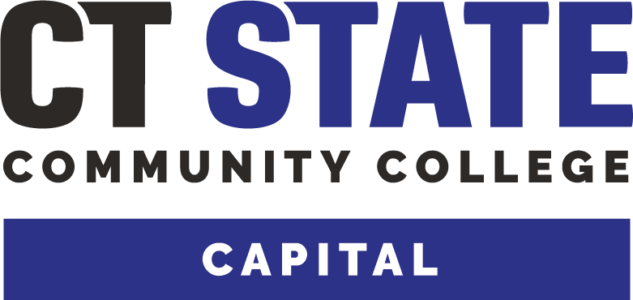 Equity Center **Fall 2024**

Office Suite 314 860-906-5212 ca-equitycenter@capitalcc.edu

       

**Book scholarships Finances Health Housing Utilities Food Transportation Legal Services**

**Please Read Carefully:** The purpose of the Equity Center is to provide essential supports so you can stay in school and be successful. The Book/Material Scholarship is to assist students who do not have the funds to pay for course materials.

Equity Center staff can assist you with removing other non-academic barriers to success. Please contact us for more information.

**Please note**: Make sure you fill out the application correctly and with required documentation. Incomplete applications cannot be processed and will delay the evaluation of application. We will review your application as soon as possible. However, the payment process may take a week. You will receive an email once your application has been approved or denied. Thank you for your patience and understanding.

**GUIDELINES:**

* For requests under $100, full payment. For requests over $100 we can pay 50%.
* Maximum amount: $400.00
* Deadline for submission: **September 6, 2024** for regular courses, **September 18, 2024** for late start courses.

**APPLICANTS MUST:**

* Be a currently enrolled student in good academic standing (2.0 GPA and above)
* Complete all questions in full on the application and submit supporting documentation.
* Complete the Single Stop Screening to learn about all the entitlement programs and resources for which you and family may be eligible: <https://app.singlestop.org/capitalcc/main>
* On Financial Avenue, complete two modules: Psychology of Money and Foundations of Money

<https://inceptia.instructure.com/enroll/MDGRM6>

* Grants do NOT have to be repaid.

**REQUIRED:**

* Attach a copy of your Account Summary (found in MyCTState under Student Self Service, “View Account Summary”)
* Attach a copy of the books need for the course(s) from your course schedule
* Have you completed Single Stop Self Screen? YES NO
* Have you completed the Financial Avenue modules? YES NO

***Please continue to fill out the application on the other side.***

**Student Information**

Date of Request: Amount of Request _________________(maximum up to $400)

Student ID # ________________________________ Date of Birth ____________________________

First Name MI Last Name

Address

City/Town State Zip

Telephone College Email

Academic Major/Program: _ _Expected Graduation Date: _____________________

Are you currently receiving financial aid or scholarships? YES NO

Please indicate household income if available

**Briefly explain why you need assistance with your books/course materials (Use additional page if necessary. If handwritten, please write clearly.)**

I swear that the information provided in this application is true.

Applicant Signature Date

***Return to Equity Center, Room 314, with required documents. If no one is there, drop it in the brown document box near the door.***

***Or send documentation to*** [***ca-equitycenter@ctstate.edu***](mailto:ca-equitycenter@capitalcc.edu)

***Equity Center For Office Purposes Only***

Date received: __________

Cumulative GPA: Approved By: ____________________________________________

Approved $______________ Denied____ Reason: